**LAB 1 TASK**

**1. DIR**

**Displays a list of files and subdirectories in a directory.**

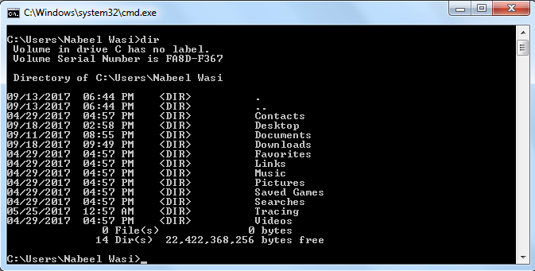

**2. MD**

**Creates a directory.**

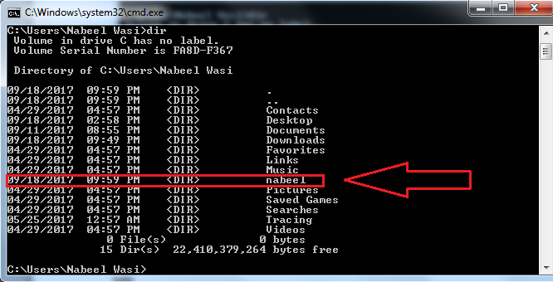

**3. CD**

**Displays the name of or changes the current directory.**

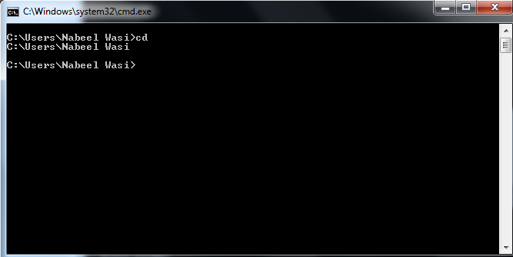

**4. DATE**

**Displays or sets the date.**

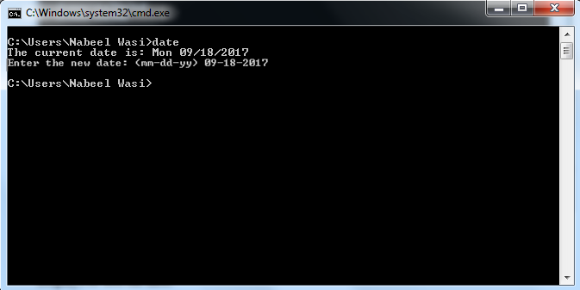

**5.RMDIR**

**Removes a directory.**

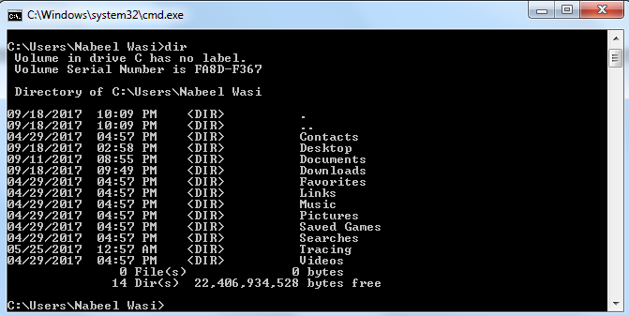

**6. VOL**

**Displays a disk volume label and serial number.**

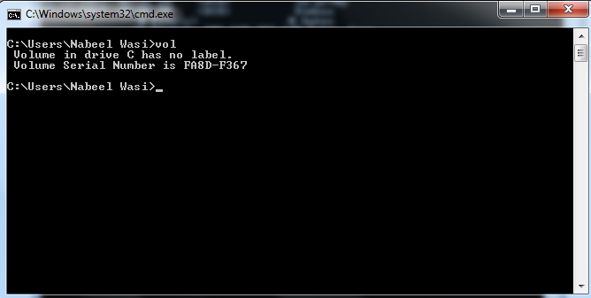

**7. VER**

**Displays the MS-DOS version.**

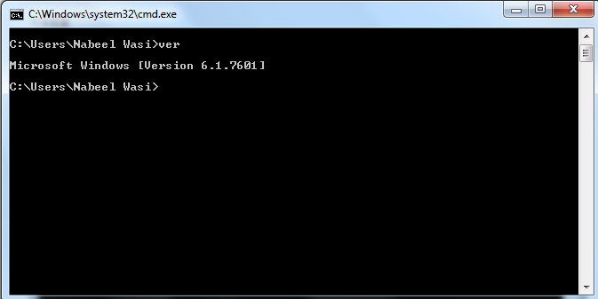

**8. ECHO**

**Displays messages, or turns command echoing on or off.**

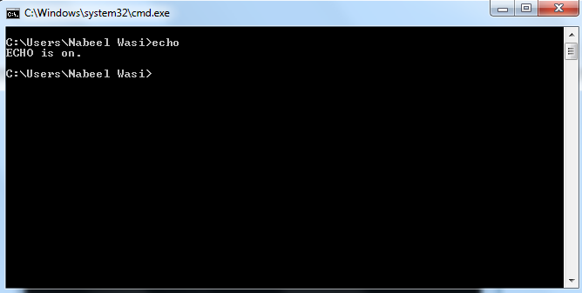

**9. PATH**

**Displays or sets a search path for executable files.**

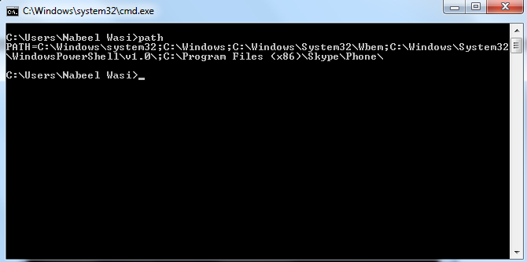

**10.DEFRAG**

**Reorganizes the files on a disk to optimize the disk.** 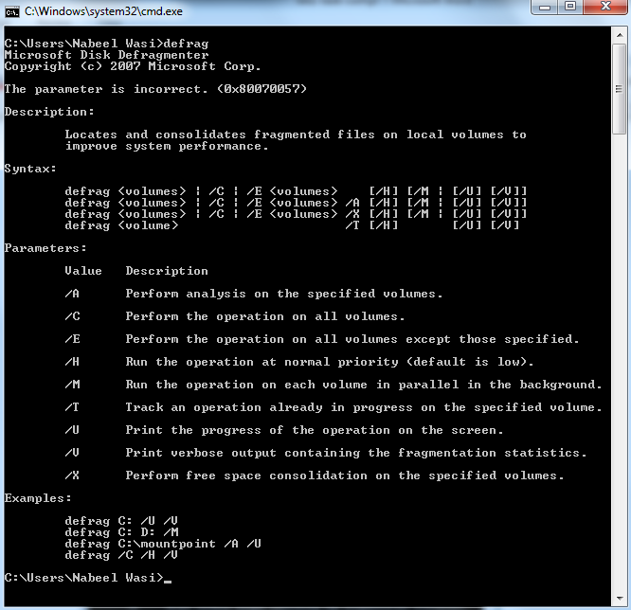

**11.ATTRIB**

**Displays or changes file attributes.**

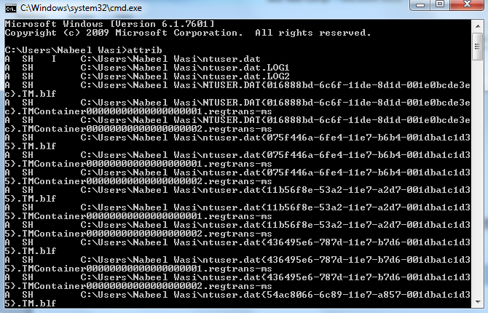

**12.LABEL**

**Creates, changes, or deletes the volume label of a disk.**

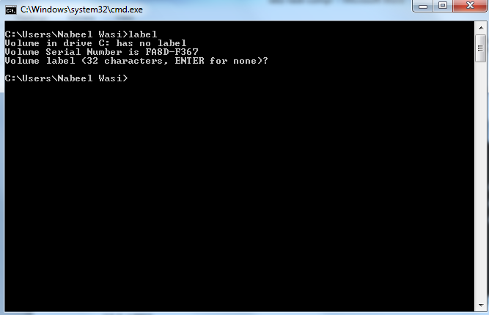

**13.MEM**

**Displays the amount of used and free memory in your system.**

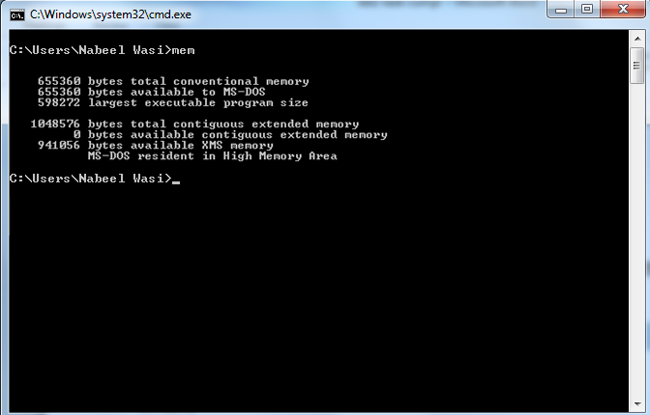

**14.MODE**

**Configures a system device.**

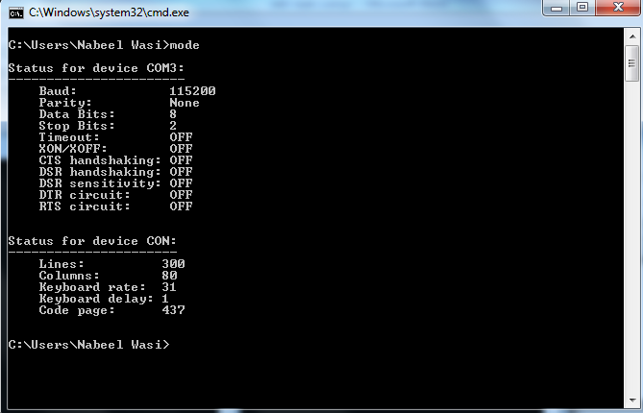

**15.TIME**

**Displays or sets the system time.**

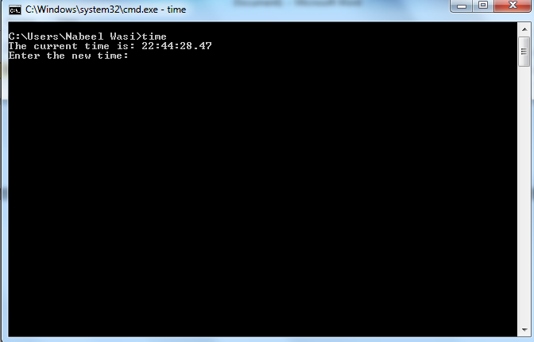

**16.EXIT**

**Quits the command.com program (command interpreter).**

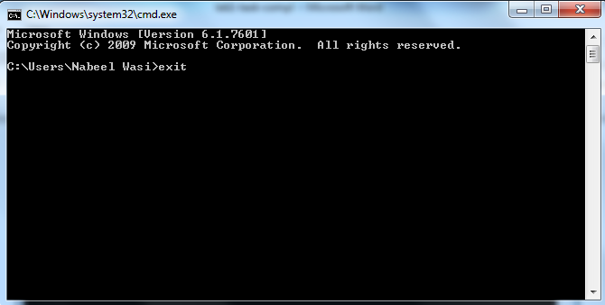

**17.REN**

**Renames a file or files.**

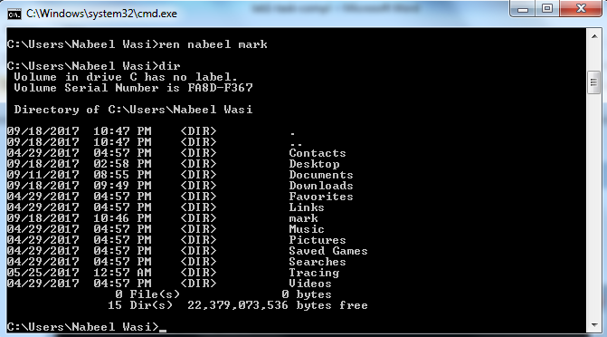

**18.CHCP**

**Displays or sets the active code page number.**

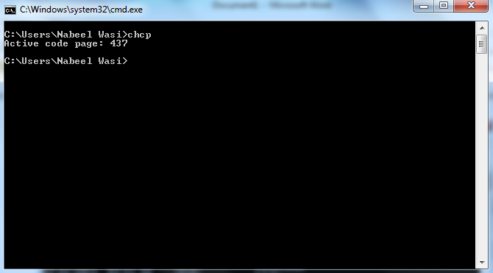

**19. VERIFY**

**Directs MS-DOS to verify that your files are written correctly to a**

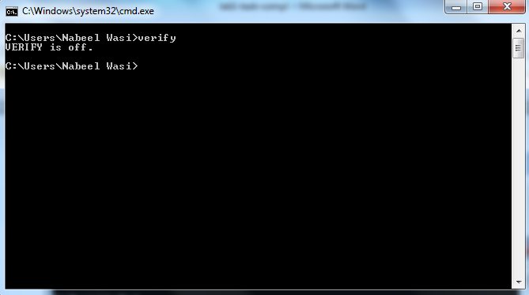

**20.COMMAND**

**Starts a new instance of the MS-DOS command interpreter.**

